 COSC 1320
Name: _________________ Terminal #__

Estimated Hours 1
Actual Hours

TA (Textual Analysis) for UML MVC CLASS Diagram MODEL
Programming Assignment 3:
(20 points.)
(due date found in the COSC 1320 BB Calendar!)
You must use Microsoft WORD program. Insert the TEMPLATEs for Actors and Use Cases in this Requirements Document.

Please have Step 1, 2, 3, 4, and 5 in this order.
Requirements Analysis: Construct the UML MVC CLASS Diagram MODEL

program for Bank Accounts

a. Define the class bankAccount to store a bank customer’s account number and balance. Suppose that account number is of type int, and balance is of type double. Your class should, at least, provide the following operations: set the account number, retrieve the account number, retrieve the balance, deposit and withdraw money, and print account information. Add appropriate constructors.

b. Every bank offers a checking account. Derive the class checkingAccount from the class bankAccount (designed in part (a)). This class inherits members to store the account number and the balance from the base class. A customer with a checking account typically receives interest, maintains a minimum balance, and pays service charges if the balance falls below the minimum balance. Add member variables to store this additional information. In addition to the operations inherited from the base class, this class should provide the following operations: set interest rate, retrieve interest rate, set minimum balance, retrieve minimum balance, set service charges, retrieve service charges, post interest, verify if the balance is less than the minimum balance, write a check, withdraw (override the method of the base class), and print account information. Add appropriate constructors.

c. Every bank offers a savings account. Derive the class savingsAccount from the class bankAccount (designed in part ( a)). This class inherits members to store the account number and the balance from the base class. A customer with a savings account typically receives interest, makes deposits, and withdraws money. In addition to the operations inherited from the base class, this class should provide the following operations: set interest rate, retrieve interest rate, post interest, withdraw (override the method of the base class), and print account information. Add appropriate constructors.

d. You need to separate the classes into their .h and .cpp files.

e. Test your classes designed in parts (b) and (c). Assume the following transactions (please add the necessary comments in the output) (DO NOT HARDCODE these inputs in your program, prompt the user for these options):

Set Account Numbers 1000, 1001, 1002, 1004 to

Create Checking Account for Jack with $1000
Create Checking Account for Lisa with $450
Create Checking Account for Samir with $9300
Create Checking Account for Rita with $32

Deposit $1000 into Jack's Checking Account
Deposit $2300 into Lisa's Checking Account
Deposit $800 into Samir's Checking Account
Deposit $500 into Rita's Checking Account

Post Interest on Jack's Checking Account
Post Interest on Lisa's Checking Account
Post Interest on Samir's Checking Account
Post Interest on Rita's Checking Account

Print Jack's Checking Account Information
Print Lisa's Checking Account Information
Print Samir's Checking Account Information
Print Rita's Checking Account Information

Jack writes a check in the amount of $250
Lisa writes a check in the amount of $350
Samir withdraws the amount of $120
Rita withdraws the amount of $290

Print Jack's Checking Account Information
Print Lisa's Checking Account Information
Print Samir's Checking Account Information
Print Rita's Checking Account Information

PLEASE DO NOT INCLUDE THESE PAGES AS YOUR DELIVERABLES! This is just for your use. Please have Step 1, then 2, etc. order in your deliverables.

UML LANGUAGE THAT MUST BE USED FOR TEXTUAL ANALYSIS!!!

UML MVC CLASS DIAGRAM MODELING:

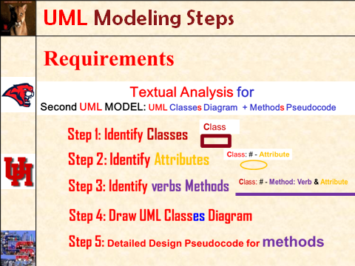

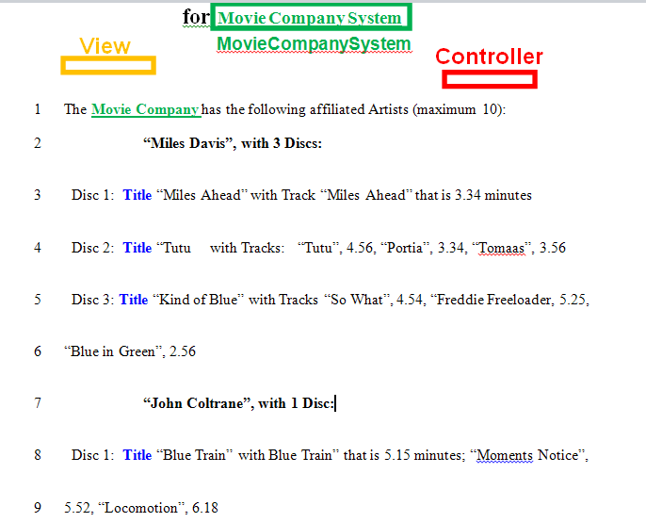
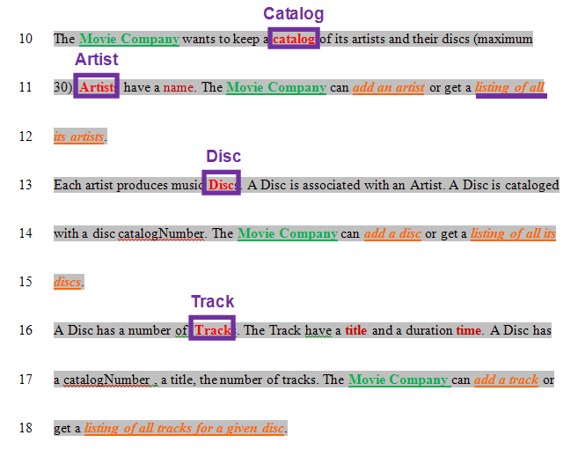
SEMANTICS: 
Class is a (first letter Upper Case) Noun.

TEMPLATE:
Class

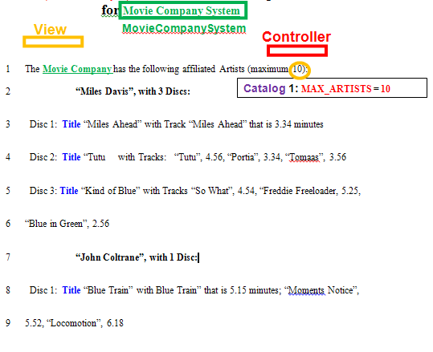
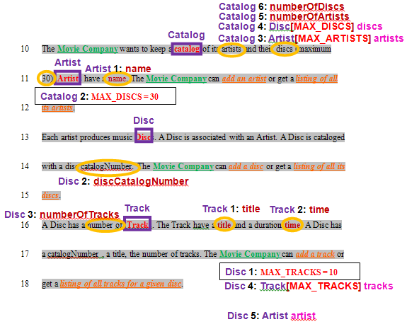
SEMANTICS: 
# - Attribute is a data Attribute for the Class and # counts Attributes for the Class

TEMPLATE:
Class: # - Attribute

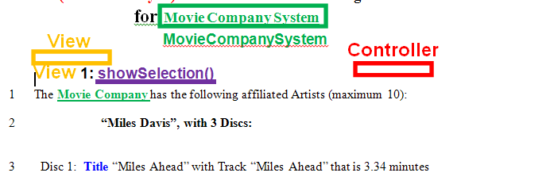
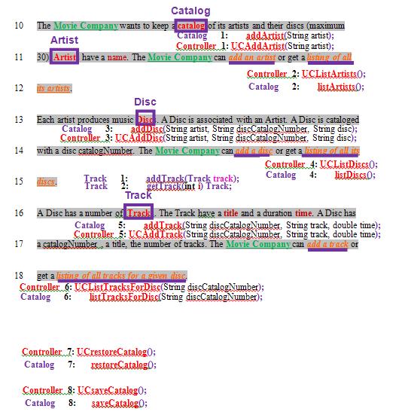
SEMANTICS: 
Method # is an operation on an Attribute for the Class and & is concatenation

TEMPLATE:
Class: # - Method: Verb & Attribute

